
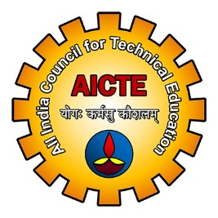 AICTE SPONSORED TWO DAY
INTERNATIONAL CONFERENCE
ON
“CONSUMER DYNAMICS AND MARKETING STRATEGIES IN A GLOBALIZED ECONOMIC ERA” – PERSPECTIVES AND CHALLENGES”
(29 -30 October, 2013)

Registration Form

Full Name :

Preferred Name :
(As preferred on Conf. name –tag & Certificate)

Designation :

University / Company:

Mailing Address :

City / State / Country / ZIP / PIN:

Phone Number: Mobile:

Home :

E – Mail(s) :

Whether Presenting Paper: Yes No

If Yes, Title of the paper
Along with the reference
Number of your paper

Registration fee deposited:
(Amount)

If Bank Draft: Bank Name/ Branch: Draft no:

If Wire Transfer/ through Account No. UTR Dated:

Date:

Station:

-------------------------------------------------------------------------------------------------------------------------------
GokarajuRangaraju Institute of Engineering and Technology, Bachupally, Kukatpally, Hyderabad – 500 090, A.P, India
Email: iccdms.griet.ac.in

AUTHOR AGREEMENT FROM (COPYRIGHT RELEASE FORM)

[ For publishing the extended abstract/full paper of your accepted research paper in the copyrighted proceeding of the conference / or a conference special issue of International Journal of Management Studies, you are here by requested to fill up this Author Agreement Form.]

I do here by surrender the copyright of the extended abstract/full paper of my / our research papertitled“___________________________________________________________________________________________________________________________________________________________________________________________________________________________________________________________________________________________________________________________” to GokarajuRangaraju Institute of Engineering and Technology, Hyderabad for publication in the conference proceedings or conference special issue of International Journal of Management Studies.

Signature of the Presenting Author (s):

Date of Conference Registration :

